The King of the Hot Dog

Summary Report

Team members: Qin Shuang

Zhou Manman

Li Huixiang

Lin Qiang

Content

1 Introduction 3

1.1 Purpose of writing 3

1.2 Background 3

1.3 Reference material 4

1.4 Definition 4

2 Project implementation 5

2.1project outcome 5

2.2Project features and performance 5

2.3 Basic process 6

2.4 Project progress 7

2.4.1Game design 7

2.4.2 Time schedule 7

2.4.3 Cost Schedule Control 10

3 Development work evaluation 10

3.1 Evaluation of production efficiency 10

3.2 Evaluation of product features 10

3.3 Summary of technical methods 11

4 Risk plan 12

4.1 Project risk definition 12

4.2 Project risk management 12

4.3 Risk management tools and methods 14

4.4 Elements of project risk management 14

4.5 Possible risks of the project 15

4.6 Specific steps for risk management 16

5 Project experience summary 17

5.1 Development team 17

5.2 Demand research 18

5.3 Do a good job in development planning 19

5.4 Good communication 19

5.5 Do a good job summary 20

6 Experience 20

7 Future plans 21

7.1 Function Optimization 21

7.1.1 Interface design 21

7.1.2 Game features 21

7.1.3 Interactivity 22

7.1.4 Reward mechanism 22

7.2 System Maintenance 22

# 1 Introduction

## 1.1 Purpose of writing

The development of The King of the Hot Dog is almost complete. At the end of the project, write this project development summary report, summarize the experience and lessons learned in the project development process, so that we can better implement the project design and development in future project development work, and develop the project in the future. There is more and more informed information in the work to standardize the development process, thus improving development efficiency.

## 1.2 Background

Project Name: Small Game Design and Development

Software Name: The King of the Hot Dog

Project Development Members: Qin Shuang、 Li Huixiang、 Zhou Manman 、Lin Wei

Development environment:

|  |  |  |
| --- | --- | --- |
| Classification | software | version |
| Operating system | Windows | Windows10 |
| Programming software | PyCharm | 3.6 |
| Interface Design | Photoshop | Adobe Photoshop CC2017 |

Operating environment：

|  |  |  |
| --- | --- | --- |
| Classification | Name | Note |
| The operating system | Windows | Default Windows |
| Hardware | CPU、The hard disk | Default minimum |

## 1.3 Reference material

（1）Related literature

* Zhang Haijun: "Introduction to Software Engineering", Fifth Edition, Tsinghua University Press;
* Xiao Gang et al., "Using Software Document Writing," Tsinghua University Press.

（2）Project development related documents

* Software Project Management Plan.
* Software project detailed design.
* Project test plan.

## 1.4 Definition

**1.Related technology:**

(1) TensorFlow is the second generation of artificial intelligence learning system developed by Google based on DistBelief. Its name is derived from its operating principle. Tensor means an N-dimensional array. Flow means that based on the calculation of the data flow graph, TensorFlow flows from one end of the flow graph to the other. TensorFlow is a system that transmits complex data structures to an artificial intelligence neural network for analysis and processing. There are four different versions of the Python language: the tensorflow, including GPU acceleration. Version (tensorflow-gpu) and its daily compiled version (tf-nightly, tf-nightly gpu)

(2) Pygame is a cross-platform Python module designed for video games, including graphics and sound. Based on SDL, it allows real-time video game development without the need to bind to the underlying languages, such as machine language and assembly language.

**2. Related abbreviation**

UML (unified modeling language) Unified Modeling Language is a standardized modeling language for software analysis, design, and programming of software blueprints. UML unifies the different perspectives of different methods for different types of systems, different development stages, and different internal concepts, thus effectively eliminating unnecessary differences between various modeling languages. It is actually a general-purpose modeling language that can be used by many users of object-oriented modeling methods. UML modeling capabilities are stronger than other object-oriented modeling methods. It is not only suitable for the development of general systems, but also for the modeling of parallel and distributed systems. UML is a modeling language, not a development process.

# Project implementation

## 2.1project outcome

The four members of the project team performed their duties and cooperated with each other. After three months, the design and development of The King of the Hot Dog was completed. The results were basically in line with the design and met the expected requirements. effect. The specific project results are explained in the PPT project demonstration in the classroom.

## 2.2Project features and performance

The purpose of developing this game is to provide a new way of playing when people are bored, so that people can achieve a good state of relaxation and efficiency. It also trains people's finger flexibility, responsiveness, judgment and observation.

According to the game function requirements, the project is mainly divided into the following three functional modules, and the rules for each functional module are described as follows:

(1) Game control module: includes controlling the start, pause, and left and right movement of the character position.

(2) Mode selection module: The main function is to select the mode of the game. Players can choose from classic mode, infinite mode or time-limited mode.

(3) Main interface display module: mainly used for menu display, background image display, game entity display.

(4) CNC module: mainly related to the timing of the game and the score of the score.

(5) Music function module: Players can choose to turn background music on and off.

All of our final products have achieved the original planned features, and additional sound effects have been added.

## 2.3 Basic process

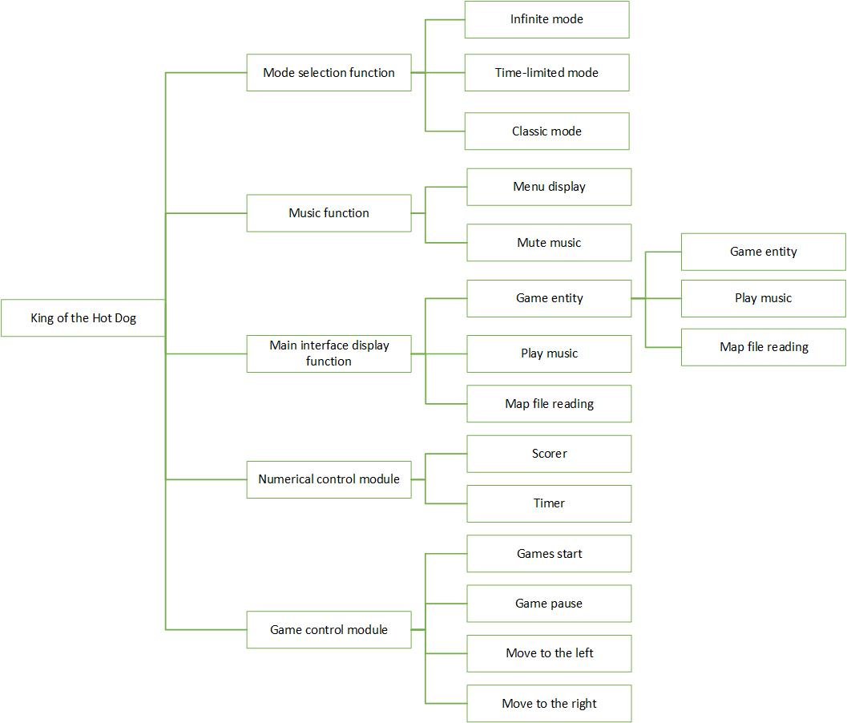

## 2.4 Project progress

### 2.4.1Game design

(1) Character design

According to the overall game style setting, the game player's image selection is from the original hand-painted version to the color short version.

(2) Game features

In order to increase the fun of the game, in the early stage of development, we changed the rules of the game from a simple mode to a mode selection according to the specific situation. In addition, in the original plan, we also added the ability to create new users and leaderboards, which can make the game more competitive.

(3) game sound effects

On the basis of background music, sound effects such as buttons and time are added, which increases the fun of the game.

### 2.4.2 Time schedule

|  |  |  |  |  |  |
| --- | --- | --- | --- | --- | --- |
| Work content | Specific work | Starting time | End Time | Time range (working days) | principal |
| Project scope planning | Determine the scope of the project | March 8, 2019 | March 13, 2019 | 4 days | 周曼曼、李慧香、覃爽、林锵 |
| Complete range planning |
| Analysis of demand | Functional requirements analysis | March 14, 2019 | March 25, 2019 | 8 days | 周曼曼、李慧香、覃爽、林锵 |
| Obtained follow-up approval |
| Complete analytical work |
| Project module planning | Develop functional specifications | March 17, 2019 | March 19, 2019 | 2 days | 周曼曼、李慧香、覃爽、林锵 |
| Develop a framework |
| According to the function rules |
| Project Development | Fan partition module | March 20, 2019 | April 26, 2019 | 28 days | 周曼曼、李慧香、覃爽 |
| Determine modularity | 覃爽 |
| UI interface design | 林锵 |
| Assign task |
| For developers |
| Project test | Write code | April 27, 2019 | May 13, 2019 | 17 days | 周曼曼、李慧香、覃爽、林锵 |
| Complete development work |
| Identify the anomaly and modify the code |
| Document | Identify substandard exceptions and modify the code | March 9, 2019 | May 14, 2019  End Time  March 13, 2019 | 48 days  Time range (working days)  4 days | 周曼曼、李慧香、覃爽、 |
| Complete all tests |
| program planning proposal |
| Detailed design of the project |

In terms of time schedule, due to the extension of our writing code time, the test time has been relatively reduced. We made some adjustments according to the actual situation, that is, the unit test work of the project was carried out simultaneously during the project development process. Fortunately, it did not delay the overall development process of our project.

In the actual development and operation process, the implementation can be carried out in accordance with the plan formulated at the beginning of the development, but also encountered some technical problems, coupled with the time relationship, causing some of the functions that are expected to be realized are cancelled.

### 2.4.3 Cost Schedule Control

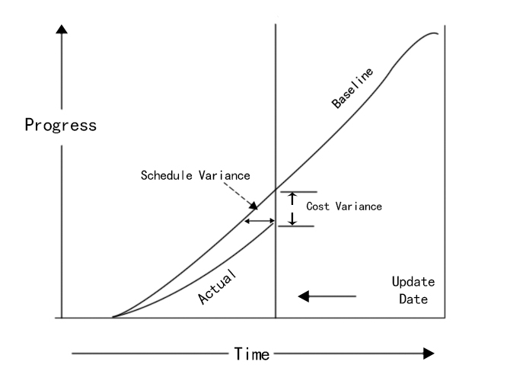

# 3 Development work evaluation

## 3.1 Evaluation of production efficiency

(1) System development has been going on for almost 3 months.

(2) The development is more repeatable.

(3) The understanding of the requirements of the system is not very thorough.

In summary, the development efficiency of this project is not very high, on the contrary, there is a considerable amount of time wasted.

## 3.2 Evaluation of product features

After the joint efforts of the four members of our project team, The King of the Hot Dog has completed the business needs of the project at the beginning of the project development. After observing the user's use process, the development of this project is quite successful, but there are still some problems, and the causes of these problems are various. For example, the design flaws of the previous system database and the construction defects of some codes, and the understanding of the requirements also have certain problems, which requires us to maintain the system for a certain period of time, to solve the new problems and project existing in the user's use. Bug. In general, the functional development of this system is relatively successful.

## 3.3 Summary of technical methods

Use technology and tools in this project：

|  |  |  |
| --- | --- | --- |
| Project management stage | | Technology and tools |
| Overall management |  | Expert judgment (teacher guidance) and team meetings |
| Scope management | Specification scope management | Team meeting |
| Collecting demand | Prototype method, brainstorming |
| Definition range | product analysis |
| Create WBS | break down |
| Determine the scope | Acceptance Test |
| Progress management |  | Gantt chart, leading map method |
| Communication management and stakeholder management |  | Stakeholder analysis, meeting |
| Risk Management | Planning risk | meeting |
| Risk Identification | Document review |
| Document management |  | Git |
| Project Development |  | PyCharm |
| UI design |  | Adobe Photoshop cc2017 |

# 4 Risk plan

## 4.1 Project risk definition

Software project risk refers to the budget and progress issues encountered during the software development process and the impact of these issues on the software project. Software project risk will affect the realization of the project plan. If the project risk becomes a reality, it may affect the progress of the project, increase the cost of the project, and even make the software project impossible. If risk management is applied to the project, the risk can be minimized.

## 4.2 Project risk management

Project risk management refers to the process of identifying, assigning, and responding to risks within the project life cycle in order to best achieve the objectives of the project. The goal of project risk management is to maximize potential opportunities or returns and minimize potential risks.

The main processes involved in risk management include: risk identification, risk quantification, risk response and risk monitoring, as shown in Figure 4-1.

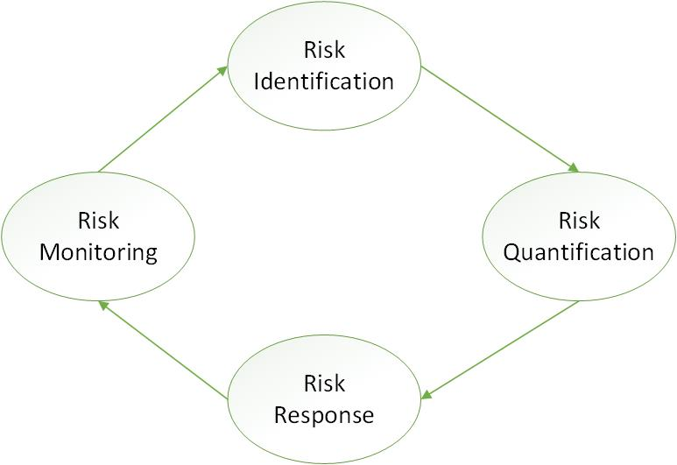

Figure 4-1

(1) Risk identification

Risk identification involves determining the source of the risk, the conditions under which the risk is generated, describing its risk characteristics and determining which risk events are likely to affect the development of the project.

Risk identification is a continuous process throughout the life of a project. That is to say, risk identification is not something that can be done at one time, it is carried out at the beginning of the project, and it is carried out regularly from start to finish.

(2) Risk quantification

Risk quantification involves the assessment of risk and risk interactions and is the process of measuring the probability of risk and the extent to which the risk affects the project objectives. The basic content of risk quantification is to determine which events need to be developed.

(3) Risk response

Risk response The process of quantifying the risk and developing a risk response strategy and technical means to reduce the negative effects of the project risk. The risk response is based on the risk management plan, risk ranking, risk perception and other basis, and the risk response plan, residual risk, secondary risk and other processes are provided.

(4) Risk monitoring

Risk monitoring involves risk response throughout the project management process. The output of the process includes corrective actions to address the risks and updates to the risk management plan.

## 4.3 Risk management tools and methods

|  |  |
| --- | --- |
| Main process | Tools, methods |
| Risk Identification | Brainstorming, interview, Delphi method, checklist, SWOT technology |
| Risk quantification | Risk factor calculation, PERT estimation, decision tree analysis, risk simulation |
| Risk response | Avoid, transfer, ease, accept |
| Risk monitoring | Checklist, periodic project evaluation, earned value analysis |

## 4.4 Elements of project risk management

（1）Recognition of the value of risk management

For organizational management, project stakeholders (internal or external), project management and project members, the investment in project risk management has potential positive returns, so project risk management should be considered extremely valuable.

1. Personal commitment / responsibility

Risk management is actually a matter for everyone, and project participants and stakeholders should be willing to take responsibility for risk-related activities.

(3) Open and honest communication

Everyone should be involved in the project risk management process. Any risk-removing behavior or attitude reduces the efficiency of project risk management relative to active processing and effective decision making.

(4) Organizational commitment

Organizational commitments can only be established when risk management is aligned with the goals and values of the organization. Project risk management requires a higher level of management support than other project management principles, as some risk responses require more advanced management approval than the project manager to take action.

(5) Quantify project investment in risk management

Project risk management activities should be consistent with the organization's judgment of the project's target value, the extent and scale of the risk itself, and other organizational-level constraints. In particular, the cost of conducting project risk management should correspond to the value that risk management can bring to projects and organizations.

(6) Integration with project management

Project risk management does not exist independently of other project management processes. Successful project risk management needs to be integrated with the correct execution of other project management processes.

## 4.5 Possible risks of the project

(1) Project risk

The game engine cannot support all images and animations, or there may be vulnerabilities in the code that affect the fluency of the game.

(2) Technical risk

The team lacks corresponding software project management experience, lack of training; insufficient understanding of methods and tools technology, lack of new technologies and development methods; unreasonable architecture, lack of good development specifications;

(3) Market risk

The market is the most direct and effective standard for testing software projects. After the game is put on the market, it can't satisfy everyone's expectations and imagination. For example, the player may feel that the game has a single function, lacks fun, and does not like the game character and background.

(4) Other unpredictable risks

Some emergencies, force majeure, etc. also constitute risk factors and are difficult to predict and avoid.

## 4.6 Specific steps for risk management

(1) Planning risk management

Planning risk management is the process of defining how to implement project risk management activities.

(2) Identify risks

A process of identifying risks that affect the project and documenting its characteristics by identifying risks.

(3) Implementation of qualitative risk analysis

Qualitative risk analysis is the process of assessing and comprehensively analyzing the probability and impact of a risk, prioritizing it, and providing a basis for subsequent analysis or action.

(4) Quantitative analysis of implementation risk

Quantitative risk analysis is the process of quantifying the impact of identified risks on the overall objectives of the project.

(5) Planning risk response

Planning for risk response is the process of developing programs and measures to increase opportunities and reduce threats.

(6) Monitoring risk

Monitoring risk is the process of implementing a risk response plan throughout the project, tracking identified risks, monitoring residual risks, identifying new risks, and assessing the effectiveness of the risk process. As shown in Figure 3-2.

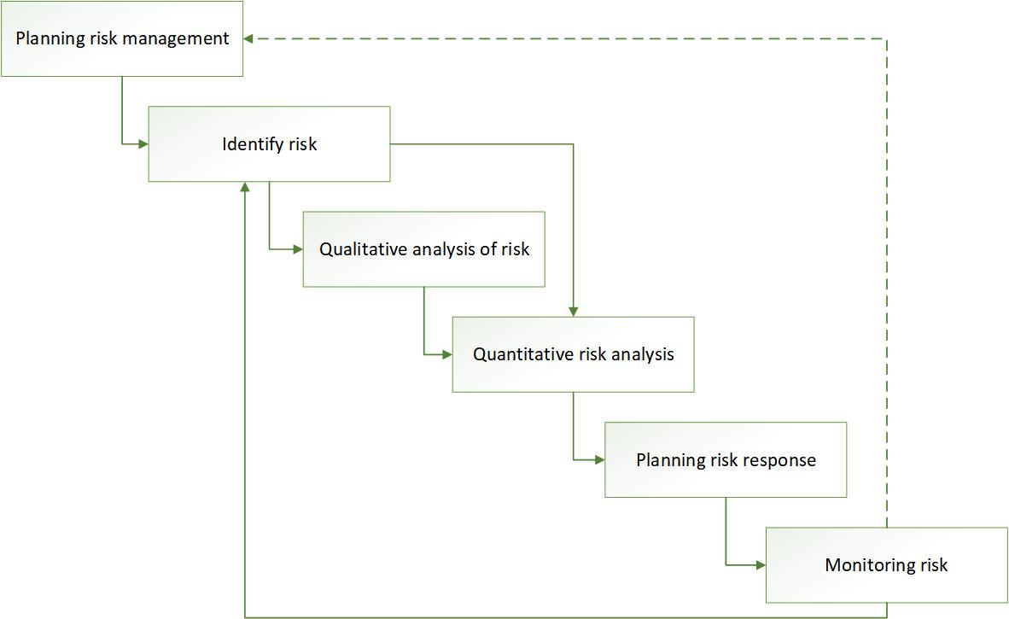

Figure 3-2

# 5 Project experience summary

## 5.1 Development team

After the project is established, the project development team should be established as soon as possible. It is very important for the team members to unite and cooperate with each other. Team members must learn from each other's strengths and technologies, and the team's ability will continue to improve. In this way, the team will not be trapped by the puzzle during the development of the project. In addition, there must be a project leader in the team, that is, the project manager. This person should be a very good person in communication with the customer or technically. The person in charge of the project should be able to communicate with the customer well. Develop members to better understand the functional needs of customers. People's memory is always limited, so developers are required to write some development documents as much as possible. These documents are often the data we need to find in the later stages of project development. The morale of the project team is a factor in the success of the project. We need to constantly cultivate our team and make our team grow stronger.

## 5.2 Demand research

After the project is established, it is in the analysis phase of demand research.

(1) If the project team does not have a sufficient understanding and good grasp of the overall organizational structure, self-positioning, personal responsibilities, etc., the project team will not be able to fully organize the project requirements, or the user's real functional requirements. So, we have laid mines for ourselves and affected the development cycle of the project. This requires us to have good friends with the users both at work and in life, and to understand the needs of users in depth.

(2) We should try our best to involve users in the development team of the project, that is, we must enable our customers to incorporate ourselves into the development team of the project, so that we can grasp the authenticity of customer needs, Reliability will be greatly improved, and it will not trap the late functional development of the project.

(3) In the process of demand research, if there is not enough user participation, such demand research also fails. Many developers are reluctant to participate in customer demand research. Why? It's very simple, it's easier to communicate with customers than to communicate with the code. Despite this, we still have to spend enough time communicating with our customers to understand their real needs. The same is true for many users, who are not willing to participate in the project's needs research. Why? Is demand research going out to be romantic with friends? ! Although this is the case, we still have to work hard to involve our customers in the research of demand.

(4) Fuzzy demand, which is ambiguous, is the most terrible problem in the specification of requirements. On the one hand, many customers have different understandings of the requirements description; on the other hand, a single reader can explain a requirement statement in more than one way. In response to this situation, we need our researchers to be able to analyze the different needs of customers from multiple angles, sort out the final requirements and customer confirmation, and determine the final real and reliable requirements. We must not rely on our own single-sided Understand to set the final needs of customers.

(5) The writing of documents is an extremely important task in the development of a project. Because some documents are the basis for our communication with customers in the late stage of development, and also the important documents that our programmers use in the coding process. We must not believe that we use our brain to record all development needs. Even if you say that you are a genius, you have to use your Einstein brain to record all the development needs, that is impossible, and people's energy is always limited. This requires us to record and organize the requirements documents in the demand survey.

(6) Demand research tool selection, customers are generally interested in graphics, so we should try to use graphical interface to communicate with customers in the research process. For example, the Rose tool can be used to convert the customer's meaning into a use case diagram, a sequence diagram, a collaboration diagram, a state diagram, a class diagram, etc., so that the meaning of the expression is more intuitive, the communication efficiency is improved, and the investigation time is saved.

## 5.3 Do a good job in development planning

After the project is established, we need to do a good project development plan, time required for research, development time, test time, implementation time, and maintenance time. After we have made the plan, we need to keep track of the completion of the scheduled tasks, so that our project schedule is within the scope of our development cycle, today's plans, actions, and tomorrow's success.

## 5.4 Good communication

Communication between people is very important, and project development is no exception. Good communication can speed up the progress of the project, which requires each of our developers to learn and communicate. In the development of a project, our communication with customers is a process of continuous communication and understanding. In the development stage, we need to communicate with the customer to have existing functions, try to avoid some hidden problems, find problems in time, solve problems, and complete project development on time or in advance.

## 5.5 Do a good job summary

In the process of project implementation, we must constantly organize our work and do a good job summary. In this way, whether in your own technology or other aspects, you will greatly improve your self. After long-term accumulation, both our personal ability and our team's ability will be greatly improved.。

# 6 Experience

Through the development of this software project, many problems that should be reflected are discovered. For example, when the team was established, due to the failure to fully understand the project and the lack of comprehensive knowledge of the relevant technical knowledge, it was not comprehensive, resulting in deviations in the progress and expected functions of the actual real-life development process. . Reflections on this issue are needed.

During the team's research and development of small games, each member showed a good spirit. The members actively cooperated and showed great passion and enthusiasm for the project development. Under the circumstances, the students supported each other and worked hard to learn relevant knowledge. Finally, with the joint efforts of all the members of the team, the research and development of the game was successfully completed.

Through these three months of development and life, we have cultivated the team spirit of each member. I believe that the three-month development process will leave a good memory for all members!

# 7 Future plans

## 7.1 Function Optimization

### 7.1.1 Interface design

The interface design of the game is directly related to the intuitive experience of the user experience game, so optimizing the interface design of the game is very necessary.

(1) Make the composition and color aspects more enriched, and increase the gif animation effect, making the whole project more vivid and three-dimensional.

(2) Design interfaces with different styles and different scenes, and allow players to switch between choices to create different game visual effects.

### 7.1.2 Game features

The function of the game is one of the most important factors for the game to gain market recognition. We can further expand and enrich the game's functions according to the player's suggestions, opinions and requirements, and enhance the player's game experience.

(1) Based on the three game modes of classic mode, time-limited mode, and infinite mode, the level of the game is increased, and the difficulty increases with the increase of the level, thereby increasing the interest of the game to attract the player.

(2) Improve the design of the game characters, design different clothes, hairstyles, ornaments, etc. for him, and allow the players to adapt their game characters according to their own preferences, to the greatest extent to meet the needs of users.

### 7.1.3 Interactivity

Can be associated with QQ, WeChat and other APP, from the stand-alone version to the online version, together with friends PK, further enhance the user's experience.

### 7.1.4 Reward mechanism

Participants liked the feeling of being pleasantly surprised and rewarded for good luck. Based on the psychology of gamers, we can set up a certain reward system for the game, so that players can not only relax, but also enjoy the pleasure during the game.

## 7.2 System Maintenance

System maintenance is to ensure the quality of the project system, to provide users with stable, reliable, timely, efficient and quality services. Through standardized maintenance requirements, the efficiency of project maintenance can be improved and maintenance costs can be reduced.

According to the project management needs such as project risk control, we divide the maintenance work into the following five categories, and different work categories adopt different management methods.

(1) New features

Add new business functions or operations based on the original functional modules of the game.

(2) Function change

According to the changes in game demand, the business functions that have been used on the line are modified, improved, expanded or changed, and offline.

The above two categories generally need to modify the source code, clear the specific functional requirements, after a rigorous functional change impact analysis, develop a specific change plan, and implement according to the development process, after the test is correct, can go online.

(3) Auxiliary operation

Auxiliary operations are divided into two parts: data-related and non-data-related. The data related work mainly involves data statistics and backtracking in conjunction with the temporary needs of users; non-data related work mainly includes transactional operations such as opening of user accounts and application software installation. Auxiliary work to support a user's better work or development does not involve code modification.

(4) Conventional operation

Routine operations are periodic system operation and maintenance tasks, including routine routine inspections, routine maintenance operations, and so on.

(5) Emergency treatment

Emergency response is to deal with all kinds of unexpected events such as system failures and software function defects, to ensure that the system can provide services as soon as possible, so as not to affect the business development and unnecessary losses.